Practicing MLA Works Citation

Sample Works Cited Page Format

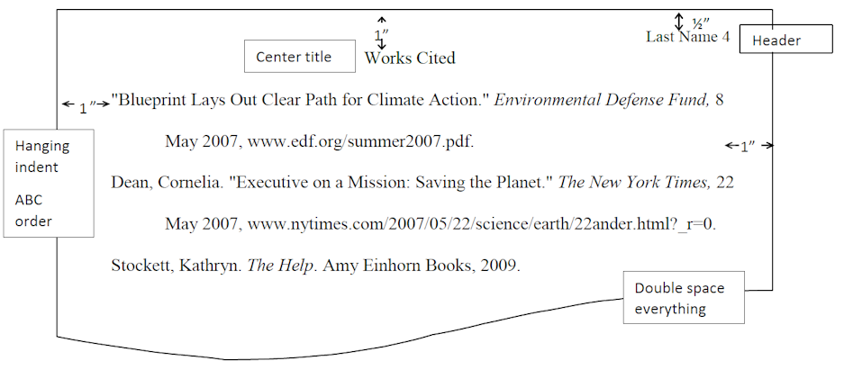

Part A – Making Citations from Webpages/Articles
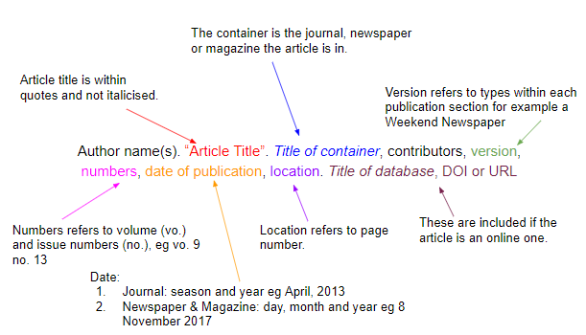
Put these into an MLA CITATION MAKER (MyBib), and create a MLA Works Cited page:
- “Tea and Bannock Stories: First Nations Community Poetic Voices” (poetry collection PDF)
https://www.sfu.ca/lovemotherearth/02poetry/tea_and_bannock.pdf
- Review of Indigenous Poetics in Canada (article in The Goose)
https://scholars.wlu.ca/cgi/viewcontent.cgi?article=1079&context=thegoose[scholars.wlu]​
- “Indigenous Literature and the Arts of Community” (issue of Canadian Literature)
https://canlit.ca/wp-content/uploads/2021/04/CanLit_230_231_FinalText.pdf[canlit]​
- “Indigenous Life in Poetry and Prose” (public library blog/reading list)
https://www.halifaxpubliclibraries.ca/blogs/post/indigenous-life-in-poetry-and-prose/[halifaxpubliclibraries]​
- “Re-Creation in Canadian First Nations Literatures: ‘When You Sing It Now, Just like New’” (journal article)
https://cas-sca.journals.uvic.ca/index.php/anthropologica/article/download/2210/1990/3220[cas-sca.journals.uvic]​

Part B – Creating a Works Cited Page with Hanging Indents
Use the citations you created in Part A and these additional citations to create a properly formatted Works Cited Page including hanging indents.
- Place Cursor at the beginning of the second line of your citation.
- Press CTRL + T – a hanging indent automatically is created.

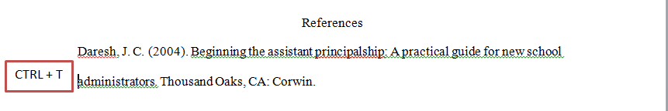
Ross, Annie, editor. Tea and Bannock Stories: First Nations Community Poetic Voices.
Simon Fraser University,
https://www.sfu.ca/lovemotherearth/02poetry/tea_and_bannock.pdf.[sfu]​
Jesson, Sheena Wilson. “Indigenous Poetics in Canada, Edited by Neal McLeod.” The Goose: A Journal of Arts, Environment, and Culture in Canada, vol. 13, no. 1, 2014,
https://scholars.wlu.ca/cgi/viewcontent.cgi?article=1079&context=thegoose.[scholars.wlu]​
“Indigenous Literature and the Arts of Community.” Canadian Literature / Littérature canadienne, no. 230–231, 2016,
https://canlit.ca/wp-content/uploads/2021/04/CanLit_230_231_FinalText.pdf.[canlit]​
Halifax Public Libraries. “Indigenous Life in Poetry and Prose.” Halifax Public Libraries, 11 Feb. 2026,
https://www.halifaxpubliclibraries.ca/blogs/post/indigenous-life-in-poetry-and-prose/.[halifaxpubliclibraries]​
Ridington, Robin. “Re-Creation in Canadian First Nations Literatures: ‘When You Sing It Now, Just like New.’” Anthropologica, vol. 43, no. 2, 2001, pp. 221–230,
https://cas-sca.journals.uvic.ca/index.php/anthropologica/article/download/2210/1990/3220.[cas-sca.journals.uvic]​

