Winter
Poems About the Coldest Season
Mr. Janzen

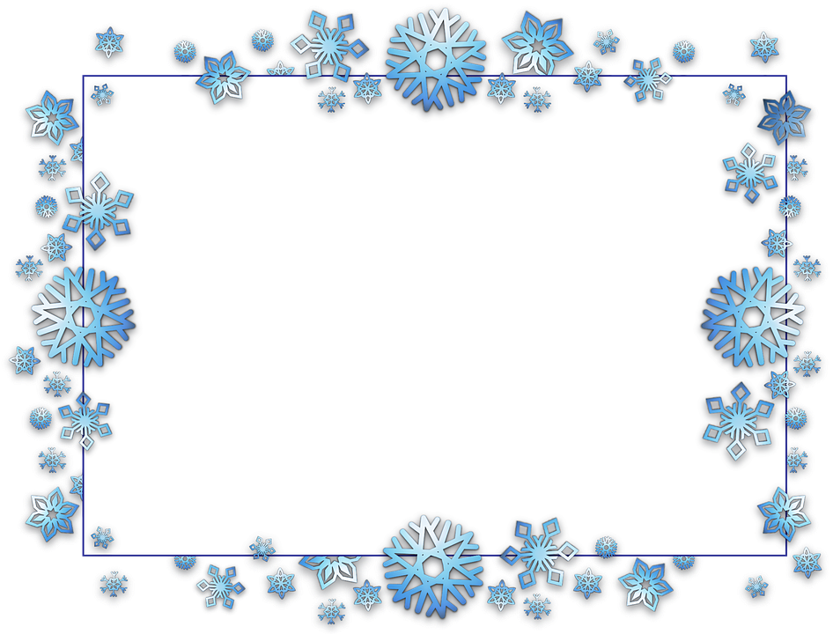
Clip Art Border put behind text from “Online Pictures”
“Old English” Font chosen to highlight the poem theme

Sonnet 97: How like a winter hath my absence been
By William Shakespeare
Drop Cap with font turned to blue and border inserted
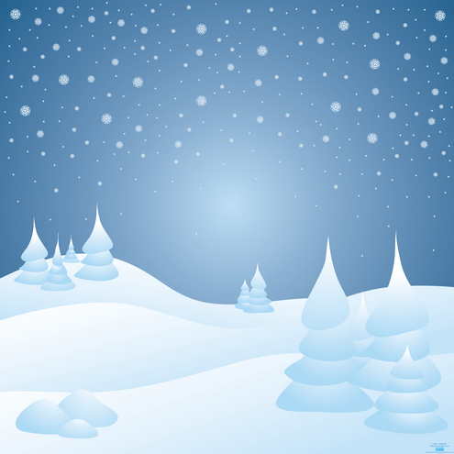
H
  - ow like a winter hath my absence been
From thee, the pleasure of the fleeting year!
What freezings have I felt, what dark dyas seen!
What old December’s bareness everywhere!
And yet this time remov’d was summer’s time,
The teeming autumn, big with rich increase,
Bearing the wanton burthen of the prime,
Like widow’d wombs after their lord’s decease:
Yet this abundant issue seem’d to me
But hope of orphans and unfather’d fruit;
For summer and his pleasures wait on thee,
And thou away, the very birds are mute;
Or if they sing, ‘tis with so dull a cheer
That leaves look pale, dreading the winter’s near.
Clip art picture placed behind text and faded with “Transparency”

