What is Fake?
How to Find Real Facts in a Misleading Online World

Thanks given to Media Smarts - https://mediasmarts.ca/teacher-resources/break-fake-how-tell-whats-true-online

Checking Your Sources - can you spot the fake?
https://mediasmarts.ca/quiz/break-fake-news

Step 1 – Use a Fact Checking Link -
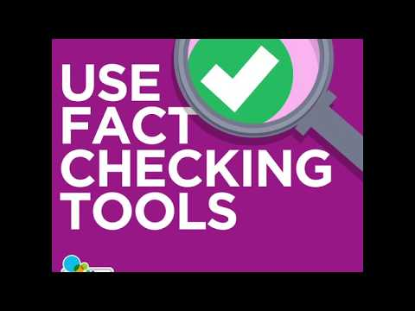

Use this link to type in key words from a news story or website and see if it turns up as misleading information - bit.ly/fact-search
If this check does not bring up information, move on to Step 2
Step 2 – Checking the Source
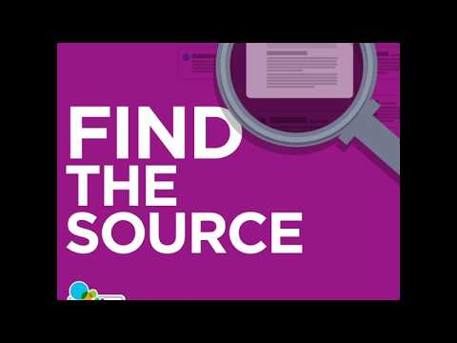
Since it’s so easy to copy and share things online, it’s important to find out where something originally came from before you decide whether or not to trust it.
- The easiest way to find the source is usually to follow links that will lead you to the original story.
- Use a search engine. See if you can find any information about where the story originally came from and do a search that includes that.

Step 3 – Verifying the Source -
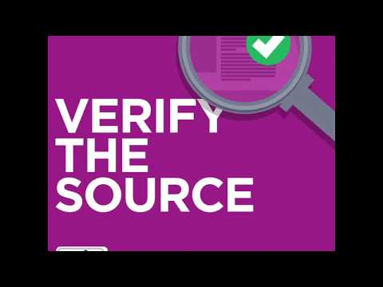
Whether you’re looking at a website, a photo or video, or a news story, what really matters is whether or not the people who originally created it are trustworthy. You can’t always confirm that something is false, but if the source isn’t reliable you have no reason to believe it.
To find out if a source is reliable, ask three questions:
- Do they really exist?
“About Us” pages and profiles are easy to fake, so use a search engine or Wikipedia to find out if other people say they really exist. Pay the most attention to things that are hard to fake.
- Are they who they say they are?
It’s easy to pretend to be someone else online, so once you know the source really exists, you need to find out if what you’re looking at really came from them.
- Are they trustworthy?
For sources of general information, like newspapers, find out if they have a process for making sure they’re giving you good information, and a good track record of doing it.
For more specialized sources, find out whether they’re experts or authorities on that topic. Do a search and make sure that they are an authority in the right field.

Step 4 - Check Other Sources

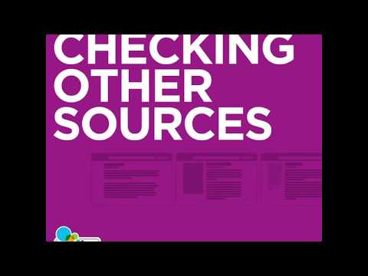
This step may sometimes be the last one you do, but it could also be the first. It’s a quick way of finding out if a source might be biased, or if a news story is true.
- The News tab is better than the main Google search for this step. While not every source that’s included is perfectly reliable, they are all news outlets that really exist.
- Our custom news search, bit.ly/news-search, searches ten Canadian and international sources of reliable news.
- You can also use this step to find out whether something fits with what most of the experts on that topic agree – what’s called the consensus view. Use our custom search bit.ly/science-search to find the consensus on specialist topics like science and medicine

.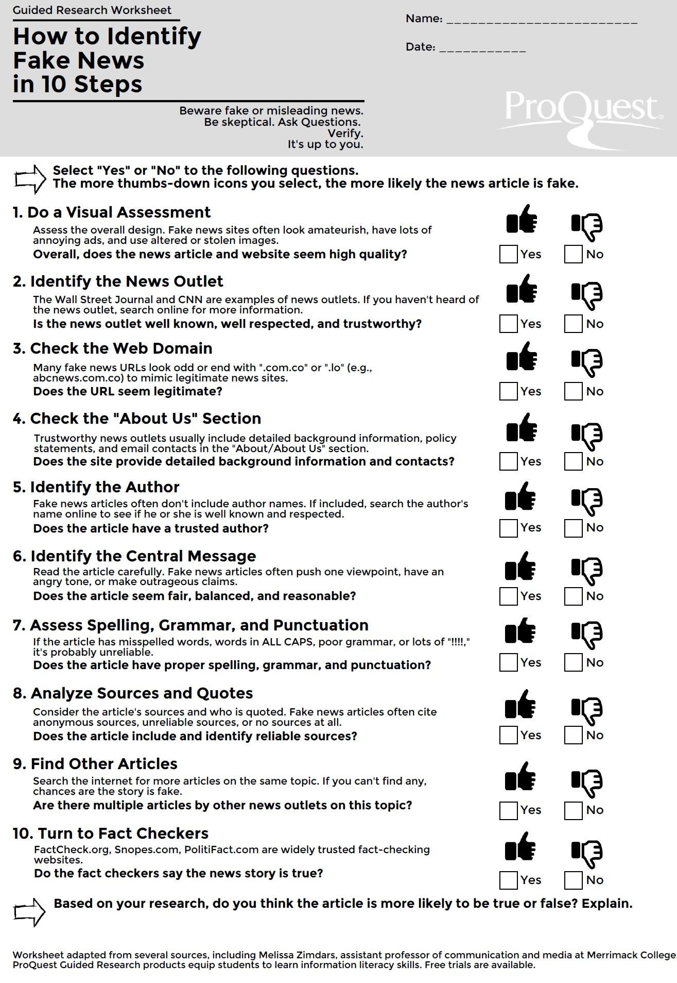

Tools to Use:
Step 1 – Use a Fact Checking Link -
bit.ly/fact-search
Step 2 – Checking the Source
- The easiest way to find the source is usually to follow links that will lead you to the original story.
- Use a search engine. See if you can find any information about where the story originally came from and do a search that includes that.
Step 3 – Verifying the Source -
- Do they really exist?
“About Us” pages and profiles are easy to fake, so use a search engine or Wikipedia to find out if other people say they really exist. Pay the most attention to things that are hard to fake.
- Are they who they say they are?
It’s easy to pretend to be someone else online, so once you know the source really exists, you need to find out if what you’re looking at really came from them.
- Are they trustworthy?
For sources of general information, like newspapers, find out if they have a process for making sure they’re giving you good information, and a good track record of doing it.

Step 4 - Check Other Sources
News search - bit.ly/news-search
Science search - bit.ly/science-search

